26 November 2020

New Golf Estate arrives in UK with more space, style and standard-fit equipment than ever before
- New Estate version of latest Golf is available to order in UK from today
- Prices start from £24,575 RRP OTR for entry-level Golf Estate Life
- Rugged new Golf Alltrack equipped with 4MOTION also on sale now

Milton Keynes – The latest generation of the Golf Estate joins its hatchback siblings in Volkswagen retailer showrooms across the UK from today, in a range comprising three stylish load-lugging models. Priced from £24,575 RRP OTR for the entry-level Golf Estate Life 1.0-litre TSI 110 PS 6-speed manual, the new model is not only the most comfortable and capacious to date but, like the hatchback range, offers the option of a digital cockpit, eTSI 48V mild-hybrid engine technology and cutting-edge safety and driver assistance systems such as Car2X. In tandem, the new Golf Alltrack also launches in the UK today – with a 2.0-litre TDI 200 PS engine combined with 7-speed DSG and 4MOTION, it is priced from £35,560 RRP OTR.
Press contact
Volkswagen (UK) Press Team

Mike Orford 07467 442062
Tom Lynch 07768 817949
Jimi Beckwith 07776 332195

Volkswagen Press and PR
Volkswagen (UK)
Yeomans Drive
Blakelands
Milton Keynes
MK14 5AN

Telephone 01908 601187
www.vwpress.co.uk
Twitter: @VWUKPress

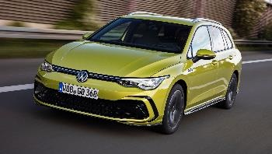 |  | 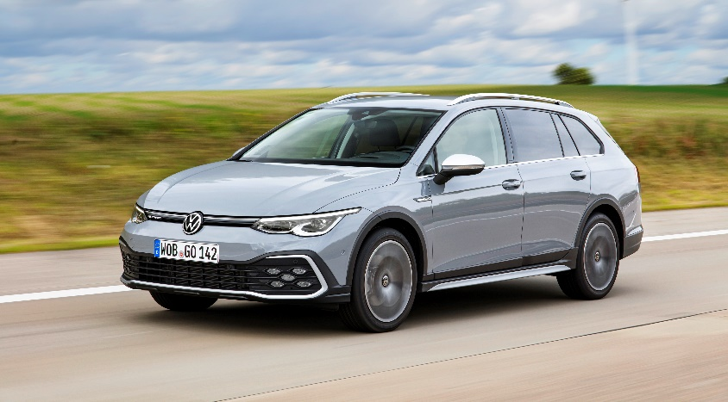
The Golf Estate is open for order now, from £24,575* |  | The new Golf Alltrack also launches today
The Golf Estate arrives in the UK available to order now in a diverse range of specification and drivetrain configurations split across three new trim levels: Life, Style and R-Line. The new Alltrack variant also makes its first appearance and is characterised by increased ground clearance, an all-terrain look and 4MOTION permanent all-wheel drive.

The initial wave of engine and gearbox options in the new Golf Estate opens with a 1.0-litre 110 PS engine, fitted with a 6-speed manual transmission as standard, but available also as an eTSI-designated 48V mild-hybrid powerplant with the brand’s 7-speed DSG transmission. Depending on the chosen Golf Estate trim level, the other engines available to order from today are a 1.5-litre 130 PS TSI, 1.5-litre 150 PS TSI, 2.0-litre 115 PS TDI and 2.0-litre 150 PS TDI, all available with 6-speed manual gearboxes. In addition, 1.5-litre, 130 PS eTSI and 150 PS eTSI mild-hybrid units are also available, exclusively with the 7-speed DSG transmissions as standard. A 2.0-litre 200 PS TDI engine with 7-speed DSG and 4MOTION is reserved exclusively for the Golf Alltrack.

Performance figures for the range of engines offered in the Golf Estate and Golf Alltrack are undeniably respectable: the Alltrack is capable of 0 to 62 mph in as little as 7.1 seconds (2.0-litre 200 PS TDI), while even the entry level 1.0-litre 110 PS TSI unit will carry the Golf Estate to 62 mph from a standing start in a sprightly 10.5 seconds.

Clearly identifiable as a sibling of the new Golf hatchback, today’s Estate family of models features a longer roof line and more muscular shoulder section which combine to give it a more overtly sporty appearance than its predecessor.

The increase in length also alters the car’s proportions, making the Golf Estate appear more substantial but also lower. The new model is 4,633 mm in length and now boasts a wheelbase of 2,686 mm (respectively 349 mm and 66 mm increases compared with its predecessor). The new Golf Estate is 1,789 mm wide and 1,455 mm high (without roof rails). In comparison, the current Golf hatchback is 4,284 mm long and boasts a wheelbase of 2,619 mm. The height and width of both Golf versions are identical.

Larger external dimensions translate into more useable space inside this new estate. Five occupants can be transported comfortably, while the car’s extra capacity is most noticeable in the rear where maximum legroom increases from 903 mm to 941 mm. Luggage space is enhanced, too, and passengers can stow their belongings in a generously dimensioned boot. When loaded to the top edge of the rear seat backrest, today’s Golf Estate offers 611 litres of storage space (six litres more than the Golf Estate Mk 7) and when loaded to the roof with the integrated luggage net partition up to the front seat backrests, the volume increases to 1,642 litres (up 22 litres).

The Golf Estate Life, Style and R-Line, and the Golf Alltrack, all offer an ascending selection of features that help mark out the new models as leaders in the fields of technology, safety and driver assistance – while every new car boasts a generous selection of standard-fit equipment.

The entry-level Life specification includes many features not traditionally seen as ‘entry level’ such as automatic LED headlamps with separate LED daytime running lights; dynamic headlight range control; tail lights incorporating LED technology; a body-coloured rear spoiler; ‘Norfolk’ 16-inch alloy wheels; interior ambient lighting with 10-colour adjustment; leather trimmed gear knob and multifunction steering wheel; Discover Navigation system with 10-inch colour touchscreen; FM and DAB digital radio receiver with six speakers; Bluetooth connectivity; App-Connect and the Volkswagen eCall emergency SOS call service.

Life buyers also benefit from the likes of Active Info Display Digital Cockpit Pro: a 10.25-inch high resolution TFT dash display screen with customisable menus; Car2X connectivity; Dynamic Road Sign Display; Front Assist and Adaptive Cruise Control; Lane Assist and parking sensors front and rear.

Step up to the Style trim and the range of design, comfort, safety and convenience features grows still further. Among the highlights for Style buyers, in addition to the features found in Life models, are: ‘Belmont’ 17-inch alloy wheels; LED ‘Plus’ headlights; High Beam Assist; front sports seats; 30-colour interior ambient lighting; 3-Zone climate control air conditioning; Side Assist and Traffic Jam Assist; and Lane Change Assist.

Golf Estate R-Line buyers can look forward to even more in the way of standard-fit equipment with, in addition to the above, 17-inch Valencia grey metallic alloy wheels; R-line body-coloured bumpers; tinted glass from the B pillar backwards; R-Line door and side trim panels; an R-Line three-spoke heated leather steering wheel; sports suspension; Driving Profile Selection; and progressive steering.
The Golf Alltrack returns with rugged, SUV-inspired styling and 4MOTION all-wheel drive which endows it with strong capability beyond paved roads. The model is also marked out as a top Golf by its honeycomb-design fog light clusters – also seen on the GT family of variants. The Alltrack receives 17-inch ‘Ronda’ alloy wheels, illuminated front grille and silver roof rails, while both driver and passengers can enjoy 3Zone climate control. Like the GT family of models, the Golf Alltrack also benefits from an enhanced suite of driver assistance systems, with Travel Assist, Emergency Assist, Side Assist and Lane Change Assist included as standard.

At launch today, the Life specification is available with three petrol engines, each with a 6-speed manual gearbox as standard, or the option to include a 7-speed DSG alongside a 48V mild-hybrid system. These are available in 1.0-litre, three-cylinder 110 PS, or 1.5-litre, four-cylinder 130 PS and 150 PS versions. The Life’s diesel option is the frugal and flexible 2.0-litre 115 PS TDI, allied to a 6-speed manual gearbox.

While Style buyers can’t opt for the 1.0-litre engines, they have the additional choice of a 2.0-litre 150 PS TDI mated to either a 6-speed manual or 7-speed DSG. R-Line models are equipped exclusively with the higher-powered, 150 PS petrol and diesel units, each offered with a choice between a manual or automatic transmission. The range-topping, 2.0-litre 200 PS TDI with 7-speed DSG and 4MOTION all-wheel drive is reserved for the Golf Alltrack, and is perfect for traversing trickier terrains than asphalt.

Lisa Hartley, Product Manager at Volkswagen UK, said: “The new generation of our much-loved family estate is undoubtedly our best yet. It’s bigger, more advanced and more refined while retaining those traditional Volkswagen values of safety, practicality and comfort that have always made the Golf a leader in its class.”

Golf Estate
Specification | Price* | CO₂ (WLTP, g/km) | MPG (WLTP, combined)
Life 1.0 TSI 110 PS 6-spd Man | £24,575 | 125-135 | 47.9-51.4
Life 1.0 eTSI 110 PS 7-spd DSG | £26,465 | 120-130 | 49.6-53.3
Life 1.5 TSI 130 PS 6-spd Man | £25,175 | 124-134 | 47.9-51.4
Life 1.5 eTSI 130 PS 7-spd DSG | £27,065 | 126-135 | 47.9-50.4
Life 1.5 TSI 150 PS 6-spd Man | £25,775 | 129-140 | 45.6-49.6
Life 1.5 eTSI 150 PS 7-spd DSG | £27,665 | 129-138 | 46.3-49.6
Life 2.0 TDI 115 PS 6-spd Man | £26,175 | 120-128 | 57.6-61.4
Style 1.5 TSI 130 PS 6-spd Man | £26,765 | 127-133 | 47.9-50.4
Style 1.5 eTSI 130 PS 7-spd DSG | £28,655 | 129-134 | 47.9-49.6
Style 1.5 TSI 150 PS 6-spd Man | £27,405 | 132-139 | 46.3-48.7
Style 1.5 eTSI 150 PS 7-spd DSG | £29,295 | 132-138 | 46.3-48.7
Style 2.0 TDI 115 PS 6-spd Man | £27,765 | 123-129 | 57.6-60.1
Style 2.0 TDI 150 PS 6-spd Man | £28,965 | 121-127 | 58.9-61.4
Style 2.0 TDI 150 PS 7-spd DSG | £30,465 | 124-130 | 56.5-60.1
R-Line 1.5 TSI 150 PS 6-spd Man | £28,075 | 133-140 | 45.6-47.9
R-Line 1.5 eTSI 150 PS 7-spd DSG | £29,965 | 133-137 | 47.1-48.7
R-Line 2.0 TDI 150 PS 6-spd Man | £29,635 | 122-126 | 58.9-61.4
R-Line 2.0 TDI 150 PS 7-spd DSG | £31,135 | 124-130 | 56.5-60.1
Golf Alltrack
2.0 TDI 200 PS 7-spd DSG 4MOTION | £35,560 | 148-151 | 49.6-49.6

* on-the-road, recommended retail price

About the Volkswagen brand:
The Volkswagen Passenger Cars brand is present in more than 150 markets throughout the world and produces vehicles at over 50 locations in 14 countries. In 2019, Volkswagen delivered 6.3 million vehicles including bestselling models such as the Golf, Tiguan, Jetta or Passat. Currently, 195,878 people work for Volkswagen across the globe. The brand also has over 10,000 dealerships with 86,000 employees. Volkswagen is forging ahead consistently with the further development of automobile production. E-mobility, smart mobility and the digital transformation of the brand are the key strategic topics for the future.
(ends)
11??? SF/tl/mo

